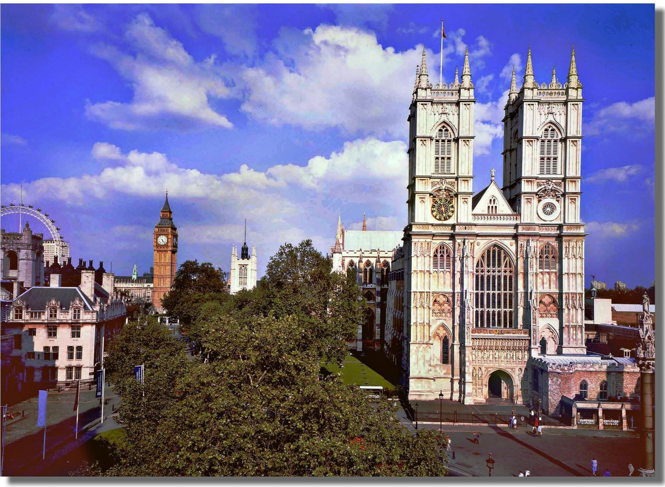DONATIONS TO **THE AMERICAN FUND for WESTMINSTER ABBEY**

**Donations of any size will make a difference and are gratefully received.**

**PLEASE COMPLETE THE FOLLOWING DETAILS AND RETURN THIS FORM WITH YOUR CHECK TO THE ADDRESS BELOW.**

Title: …………… Name(s):………………………………………………………………

Address…………………………………………..........................................................

…………………………………………….................. City ……………………………..

State: ………………………………………………… Zip Code: ………………………

Email: ………………………………………………... Phone: …………………………

I would like to be kept informed about events or associated activities of Westminster Abbey in the US and UK.

Amount enclosed (US dollars only) $…………………………………………………..

(Please make checks payable to the American Fund for Westminster Abbey).

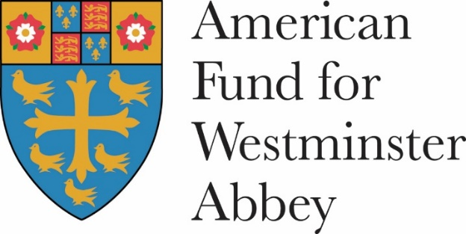Mrs Kazie Metzger Harvey

American Fund for Westminster Abbey

111 East 56th Street, Suite 211

New York, NY 10022

E: info@af-wa.org